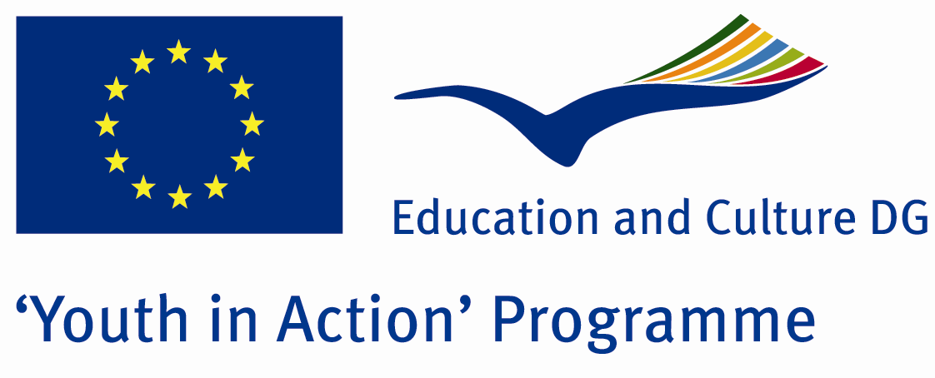

Money, Money, Money…



ACTION 1.1 – Youth Exchange

13-20th August, 2011

Tekirdag, TURKEY

ACTION 1.1 Youth Exchange
13-20th April, 2011
Tekirdag, TURKEY

Please contact directly to;
adventurerpeacepigeons@gmail.com

Project Summary;

The Money was invented by Historic Lydia country…and From beginnig of invention up to now, it has been a symbol of strength and richness…during the eras, the Money was seen us in dffrent situations.Some countries showed their cultures in their Money, some of them showed their heroes…Sometimes, countries tried to give their ideological learnings to the world with their own money…To sum up, Money is sometimes a culture, sometimes is a teacher and sometimes is a vehicle for dirty activities…It is not important what happened..money is important and valuable…but in this Project we dont talk about its value (as price)…We interest in its cultural value…if you want to join this Project, please contact us….

Project Title; Money, money, money…

Date and Venue ; 13-20th August, 2011 Tekirdag, Turkey.

Target Group ; Municipalities, City Councils and Non-Governmental organizations,
youth groups,culture and art groups,e.t.c

Participants ; 5 people from each country (over 18 -25 ). Totally 8 countries.

Conditions ; Accommodation, board and programme costs will be financed through European Commission Youth in Action Programme (Action 1.1). Travel costs will be reimbursed in 70% (APEX Tarrifs). Organizations from all 27 EU member countries plus Liechtenstein , Norway and Iceland are eligible to take part.

Working language: English

Organizer; Adventurer Peace Pigeons

How to apply: If you are interested, please send your Part III forms to
0090 216 494 39 98 by FAX please. (Fulfilled Part III which you can find in the attachment, of course signed and stamped) ..

Note: jpeg is not allowed..please send by fax…

Next step 2;
Original send via regular post to this address please:

Ertan DERİN
Öner İnşaat
Abdulhalik Renda Cd.
Parlar Sk. No:4 Pendik/İSTANBUL

If you have any questions you may contact with: adventurerpeacepigeons@gmail.com

Deadline for application; until 20 March 2011.

For Further information:
Contact Person
Ertan DERİN
Öner İnşaat
Abdulhalik Renda Cd.
Parlar Sk. No:4 Pendik/İSTANBUL

e-mail : adventurerpeacepigeons@gmail.com
Mobile : 0090 542 393 93 90
Fax : 0090 216 494 39 98

